http://www.fao.org/docrep/004/x3936e/x3936e10.htm
Implications of Economic Policy for Food Security : A Training Manual

Annex 2 : Theoretical Concepts for the Analysis of Economic Policies
Annex 2a : The Salter-Swan-Model
1. Introduction
1. Model assumptions
The Salter-Swan-model has been developed by two Australian economists Salter and Swan in the1950s. It serves two purposes: first, it helps to understand the role and interaction of critical factors inducing macro-economic disequilibria, and second it provides a framework in which the rationale behind and the likely consequences of policy interventions, including policies subsumed under 'adjustment', can be analysed.
At the core of the model is the distinction between 'tradable' and 'non-tradable' goods and services. Tradables comprise all goods and services produced in an economy which are actually or potentially imported or exported. Non-tradables are goods and services which do not cross country borders, either because transport costs prohibit the export or the import of a good, or due to the virtually non-tradable nature of the goods in question (e.g. public services, land, housing, construction, local specialities which are not traded on the world market, highly perishable products). Most agricultural products, including food crops which are (partly) imported as well as cash crops for export, belong to the category of tradables.
The most notable difference between tradables and non-tradables arises from the process of price formation. In an open dependent economy (dependent means that a country is a price taker on the world market), the price of tradables is assumed to be determined by world market prices (expressed e.g. in US-$), 'translated' through the exchange-rate into domestic market prices (for details see Annex 2B on the exchange rate-price-market mechanism below). The prices of non-tradables are assumed to be determined by domestic supply and demand.
The tradable-non-tradable distinction on which the model is based helps us to capture important aspects of macro-economic processes of price formation and production response. It is, however, not free of conceptual ambiguity. In practice, a large range of products cannot be clearly assigned to one of the classes but are characterised by different degrees of 'tradability'. Even within a country, the same product may be a tradable at one place (close to the border, the main trading or consumption centres), and non-tradable at another place (in remote and inaccessible areas). The fact that most goods fall somewhere in between the extreme cases of tradables and non-tradables has consequences on the process of price formation which will be discussed at the end of this chapter.
The major assumptions, on which the model are based, are in summary (for details see references):
i) Three types of a commodities are produced: an exportable (x), an importable (m), and a non-tradable (n).
ii) The prices of tradables (Px and Pm) are given by the world market, translated through a fixed nominal exchange rate (equalling the real exchange rate in the initial equilibrium situation, see Annex 2B on exchange rate price-market-mechanism below) into domestic market prices. The price of the non-tradable (Pn) is determined by domestic supply and demand.
iii) Importables and non-tradables are only for final consumption and not used as intermediates in the production process, while the exportables are completely exported and not domestically used.
iv) As the price of tradables is given and fixed, the terms of trade (Px/Pm) are also fixed, and the exportable and importable commodity can be combined into a single composite tradable commodity (t) with price Pt (= Px/Pm). Although, by definition, consumption only relates to importables (see 3), it may be either be directly related to domestically produced importables, or indirectly through the production of exportables which are exchanged for the same value (assuming a current account balance) of imported consumer goods.
v) Product and factor (labour and capital) markets are perfectly competitive and the economy produces at its production frontier. Labour is completely mobile in the short-run, (will shift from one sector to another according to the market conditions), while capital is sector-specific in the short-run and mobile only in the long-run.
2. Features of the macro-economic optimum and equilibrium
Figure 1 depicts an equilibrium situation which we use as the starting point of the analysis. The axes indicate the quantity of tradable and non-tradable goods which are produced and purchased (demanded) in an economy.
Figure 1: Macro-economic equilibrium
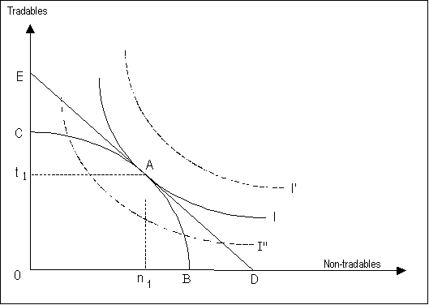<="">
The curve BC represents the production transformation curve. It traces all possible combinations of tradable and non-tradable goods which may be produced in the economy, given the available natural resources, production factors and technology. It is also called the production frontier or production possibility curve, as it is the locus of maximum production combinations at full employment of all production resources. If all productive resources were devoted to the production of non-tradables, the quantity B could be realised, if only tradables were produced, the quantity C could be realised, or any combination of n and t on the curve BC, e.g. the combination A. Any combination below the curve BC means that not all production resources are used (under-employment) and that the economy does not fully realise its productive potential.
In the short run the curve is fixed, while in the long run it may contract or expand through changes in the resource endowment or the technology applied. Economic growth can be shown as an expansion (right-upward shift) of the transformation curve. Here it is assumed that the curve is given and fixed.
I, I' and I'' represent a sample of (an unlimited number of) indifference curves. One indifference curve shows the consumers' preference between tradables and non-tradables at a constant level of utility. I'' stands for a lower level of satisfaction or welfare than I, while I' signifies a higher level of utility. The typical concave shape of the indifference curves is based on the plausible assumption that the consumers need to substitute a certain amount of tradables with an increasing amount of non-tradables (and vice versa) in order to maintain the same level of utility. To give an example: If somebody had an abundant supply of rice (tradable) but no vegetables (non-tradable), he would be prepared to exchange a substantial amount of rice for a little quantity of vegetables. The more vegetables he has already, the smaller the amount of rice he would be prepared to give in exchange for an additional amount of vegetables.
Assuming rational economic behaviour, a household will try to attain the highest possible level of utility with the income (or expenditure budget) available. The budget line is given by the line DE which represents the combinations of tradable and non-tradable goods which can be purchased at a given amount of income (expenditures) and at given prices of t and n. The slope of the DE curve is determined by the price relation (internal terms of trade) Pt/Pn. If all expenditures were devoted to non-tradables, the quantity D could be purchased at the given price, or the quantity E, if all money is spent for tradables. These cases are, however, not feasible under the given conditions, as the maximum quantity of non-tradables which the economy produces is given by the level B, the maximum quantity of tradables is given by the level C (The implications of an excess demand over production are discussed further below).
The only point where the given budget line meets the production possibility frontier is A, where the quantity n1 of non-tradables and the quantity t1 of tradables are produced. Point A represents, at the same time, the point where a household (or the economy as a whole as assumed in the model) can realise its maximum level of welfare with a given level of income, by allocating the budget to buy n1 quantities of non-tradables and t1 quantities of tradables. At point A, the marginal costs of production of tradables/non-tradables are proportional to the relative prices (line ED, and the marginal rate of production substitution (tangent to BC curve) is equal to the marginal rate of consumption preferences (tangent to I curve).
In summary, point A represents the theoretical optimum as well as the only equilibrium situation, characterised by the following features and conditions:
- the demand for tradables and non-tradables equals supply,

- the economy achieves the maximum level of welfare at a given income and income distribution,

- full employment of all production factors,

- the demand for tradables equals production, and imports equal exports, hence the

- exchange rate is in equilibrium,

- the demand for non-tradables equals production,

- all parameters (production, demand, prices, exchange rate) are in a stable position.
Although, in reality, such an ideal situation can never be found, economic theory assumes that an economy tends to develop towards such an equilibrium point, even after having been exposed to macro-economic shocks (which may put the economy into a state of disequilibrium for a while), if it is not hindered by distorting factors. Major distortions arise from demand manipulation and market rigidities resulting from government deficit spending and monetary expansion in combination with exchange rate controls. Such factors are introduced in the next step of the analysis.
3. Distortions of the macro-economic equilibrium
It is assumed that a rise in government expenditures, incurring a budget deficit being financed by monetary expansion (printing of money), has pushed demand to point F in Figure 2 (or any other point outside the production frontier). We get a situation where demand exceeds production, in our case of both tradables (t2-t1) and non-tradables (n2-n1). In an ex ante view, before the additional money is actually spent and before prices have changed, the new expenditure line is given by GH which runs parallel to the income line DE.
Any combination of demand to the right of point A means an excess demand for non-tradables, any combination above A implies an excess demand for tradables and a current account deficit. If prices and the exchange rate were not controlled, domestic prices would rise in both cases: directly due to excess demand in the case of non-tradables, indirectly in the case of tradables through the market-price-exchange rate mechanism (world market prices are assumed to be given and fixed). A balance between production and demand and a new equilibrium will be re-established by inflation: income and demand will increase in nominal terms but remain the same in real terms while the quantity of production remains the same throughout. In our graph (which depicts the real values), the expenditure curve shifts back to its original position (indicated by the straight arrow).
If there were a change in the structure of demand for tradables and non-tradables (change of the indifference curves) associated with the expansionary fiscal/monetary policy, the relative prices (internal terms of trade) would change, as the rates of inflation of tradables and non-tradables would be different and induce a relative shift in the production structure towards the commodities with relative price increases. In the case of an excess demand for non-tradables, the budget line would rotate clockwise in point H to line IH (non-tradables get relatively more expensive) with the new equilibrium point at A', where more non-tradables and less tradables are produced than at point A. In the case of an excess demand for tradables, the budget line would rotate counter clockwise in point G to line JG with the new equilibrium point at A'', implying a shift in the production pattern from non-tradables to tradables.
Figure 2: Macro-economic changes induced by excess demand
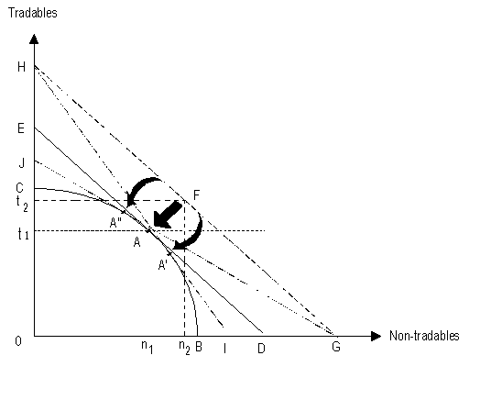<="">
4. Perpetuation of a macro-economic disequilibrium
The results will be different if, in combination with an excess demand situation, a fixed exchange rate policy is pursued by the Government. Figure 3 traces such a situation.
Figure 3: Perpetuation of a macro-economic disequilibrium
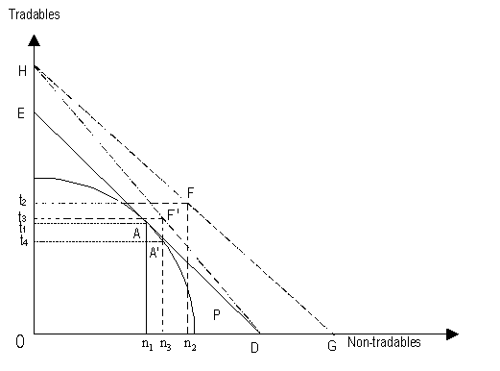<="">
When the exchange rate is fixed, only the prices of non-tradables increase as a result of an increase in demand from A to F, while the domestic prices of tradables are not affected. Due to the price increase of non-tradables, the expenditure line rotates through H to the new position DH. The new point of aggregate demand is F' where n3 non-tradables and t3 tradables are purchased. Due to the change of relative prices in favour of non-tradables, production of non-tradables increases from n1 before to n3 and is in equilibrium with demand for non-tradables. (The tangent of the production possibility curve in point A' has the same slope as the new budget line). As to tradables, demand has increased from t1 to t3, while production has gone down from t1 to t4. In the new situation (F'), demand for tradables exceeds production by t3-t4 with a corresponding foreign trade/current account deficit.
F' can only be maintained if the balance of foreign exchange required is made available, for example, by a depletion of the country's foreign exchange reserves, by substantial capital inflows, e.g foreign aid, foreign investments, remittances from emigrants working abroad, or, last but not least, foreign credits. The latter source of financing a trade deficit has been common practice but, as experience shows, has only provided short-term relief and led to no sustainable solution.
5. Main conclusions from the model analysis
The Salter-Swan-model provides evidence on the major factors causing structural imbalances and the role of macro-economic policies in either reinforcing or mitigating the dynamic of macro-economic disequilibria. The main conclusion from the model analysis for the design of economic policies design is clear:
Reduce policy interventions which impede market processes and encourage market forces to establish a state of macro-economic equilibrium. Even if a disequilibrium emerges which may be induced by external or internal shocks, any policy intervention should be in the direction indicated by market forces (Adam Smith's invisible hand of the market) to find a way towards establishing a new macro-economic equilibrium. This is the basic philosophy behind IMF and World Bank assisted adjustment programmes.
However, in spite of the clear and simple conclusions which can be drawn from this analysis, critical reservations need to be raised as to the validity of certain assumptions in the model and to an unthinking mechanistic application of the messages resulting from use of the model in policy formulation:
This model presents a purely economistic view. It abstracts, for example, from all supply and demand factors which are not transmitted through the market and are not expressed in market prices. This refers, for example, to all goods and services provided within the household economy as well as all those needs which are not expressed as effective monetary demand. As to the food economy, all sources of food entitlement bypassing the market channels (subsistence production, non-market transfers) as well as food needs of the poor who lack the purchasing power to articulate their needs as effective market demand are ignored. If such factors are overlooked in policy formulation, this implies a neglect of major productive forces and of important aspects of social welfare. It would mean, for example, that a purchase of (effective demand for) weapons counts as a increase in welfare while the food needs of poor with insufficient purchasing power are left out of consideration.
The clear distinction between tradable and non-tradable goods on which the model is based with the implied assumptions concerning price levels and price formation processes does not comply with reality. While there are certain sectors whose outputs largely fall under one of these categories (e.g. cash crops for export under tradables, most government and many other services under non-tradables), there is a wide range of goods, including most food commodities, which fall somewhere in between the pure categories. This means, in effect, that the prices of such goods are neither exclusively determined by world market prices (as assumed to apply to tradables) nor exclusively by domestic supply and demand factors (as assumed to apply to non-tradables). Some of the factors which imply diversions from the model assumptions are as follows:
- The degree of tradability of a good varies between different regions, due to transport costs and depending on the existing marketing and physical infrastructure. Generally it can be assumed that the number of tradable goods is much greater in border areas and close to major cities than in remote rural areas. Many goods belonging to the tradable category in the first instance may be non-tradables in the latter case.

- The degree of tradability varies over time, depending on changing price differentials between different areas. If, for example due to a currency devaluation, the price for imported food rises substantially in the major consumption centres, a good produced in a remote area and belonging to the non-tradable category before may start to be sold to the cities, hence to developing into an importable or import substitute.

- Although some local food products are non-tradables, they function as imperfect or quasi- substitutes for importable food commodities. This applies to inferior low-cost food commodities such as cassava and millet. If, due to a currency devaluation, the prices of imported foods increase, the demand for cheaper import substitutes expands. The increased demand will, contrary to the model assumptions, probably lead to price increases in this category of non-tradables, too.

- Many imported goods have some local value-added components in their final consumer price (e.g. transport, storage and marketing costs) which are non-tradable. On the other side, many non-tradable goods have some imported components (e.g. production inputs).

- The existence of market monopolies in export and import sectors implies particular price formation processes. In order to remain competitive, a trader dealing with imported food may be prepared to reduce his monopoly margin and increase the price less than would be expected from a currency devaluation. On the other hand, an exporter may retain a percentage of the extra profit incurring from a currency devaluation and not pass it on to the producers.

- There are further reasons why the prices of tradables and non-tradables do not behave as assumed in the model, e.g. economies of scale in export and import marketing, trade barriers, depressing effects of simultaneous adjustment in a number of countries on world market prices of export commodities, imperfect market information.
Many goods are likely to be subject to more than one of the factors mentioned above. All these factors, taken together, imply that the prices of most goods behave in a way which falls somewhere in between the extreme cases of tradable and non-tradable goods.
References
FAO, A Model for Structural Adjustment - The Salter Swan Model - , Introductory Seminar on Food and Agriculture Policy Analysis (Morogoro - May 1990), Training Paper No. 2, October 1989.
Woodward, D., Debt, Adjustment and Poverty in Developing Countries, Vol. II, Save the Children, London 1992.
World Bank, Making Adjustment Work for the Poor, A Framework for Policy Reform in Africa, Washington D.C. 1990.

